|  |
| --- |
| **LAPORAN PRAKTIKUM JARINGAN KOMPUTER**  **1.4.7**  **PACKET TRACER – CONFIGURE ROUTER INTERFACES** |
|  |
| **Agus Pranata Marpaung**  **13323033**  **DIII TEKNOLOGI KOMPUTER** |
| **INSTITUT TEKNOLOGI DEL**  **FAKULTAS VOKASI** |

**Judul Praktikum**

|  |  |  |
| --- | --- | --- |
| **Minggu/Sesi** | : | IX/2 |
| **Kode Mata Kuliah** | : | 4332101 |
| **Nama Mata Kuliah** | : | JARINGAN KOMPUTER |
| **Setoran** | : | Jawaban dalam bentuk *softcopy* |
| **Batas Waktu Setoran** | : | *Sesi Praktikum Selanjutnya* |
| **Tujuan** | : | 1. Mahasiswa dapat mengimplementasikan sebuah jaringan komputer dalam skala kecil pada simulator. |

**Petunjuk**



**Packet Tracer - Configure Router Interfaces**

**Addressing Table**

|  |  |  |  |
| --- | --- | --- | --- |
| **Device** | **Interface** | **IP Address/Prefix** | **Default Gateway** |
| R1 | G0/0 | 172.16.20.1 /25 | N/A |
| *R1* | G0/1 | 172.16.20.129 /25 | N/A |
| *R1* | S0/0/0 | 209.165.200.225 /30 | N/A |
| PC1 | NIC | 172.16.20.10 /25 | 172.16.20.1 |
| PC2 | NIC | 172.16.20.138 /25 | 172.16.20.129 |
| R2 | G0/0 | 2001:db8:c0de:12::1/64 | N/A |
| *R2* | G0/1 | 2001:db8:c0de:13::1/64 | N/A |
| *R2* | S0/0/1 | 2001:db8:c0de:11::1/64 | N/A |
| *R2* | *S0/0/1* | fe80::2 | N/A |
| PC3 | NIC | 2001:db8:c0de:12::a/64 | fe80::2 |
| PC4 | NIC | 2001:db8:c0de:13::a/64 | fe80::2 |

**Objectives**

**Part 1: Configure IPv4 Addressing and Verify Connectivity**

**Part 2: Configure IPv6 Addressing and Verify Connectivity**

**Background**

Routers R1 and R2 each have two LANs. Your task is to configure the appropriate addressing on each device and verify connectivity between the LANs.

**Note**: The user EXEC password is **cisco**. The privileged EXEC password is **class**.

**Instructions Part 1: Configure IPv4 Addressing and Verify Connectivity**

**Step 1: Assign IPv4 addresses to R1 and LAN devices.**

Referring to the **Addressing Table**, configure IP addressing for **R1** LAN interfaces, **PC1** and **PC2**. The serial interface has already configured.

**Answer:**

In this command, the two Gigabit Ethernet interfaces on Router R1 are configured with their respective IP Addresses and enabled. This allows the router to direct network traffic between two different subnets, connecting devices in subnet 172.16.20.0/25 and subnet 172.16.20.128/25.

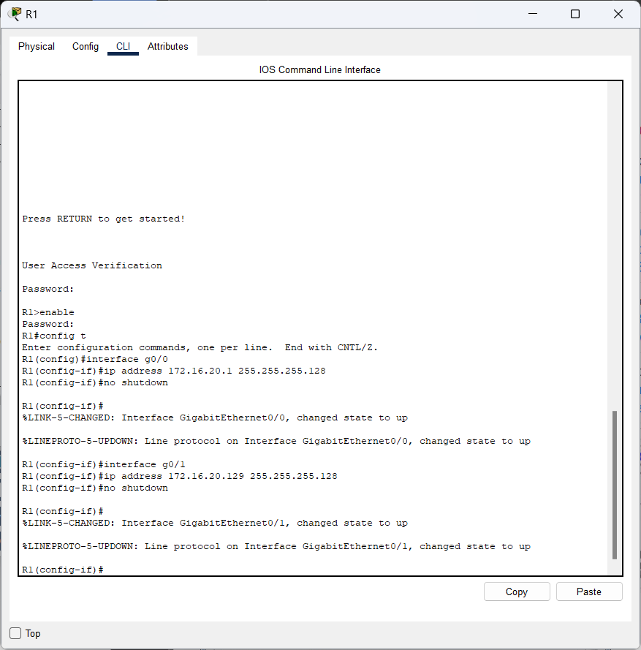

Then, we input the IPv4 address, subnet mask, and default gateway in IP Configuration on PC1 and PC3 in the Address Table.

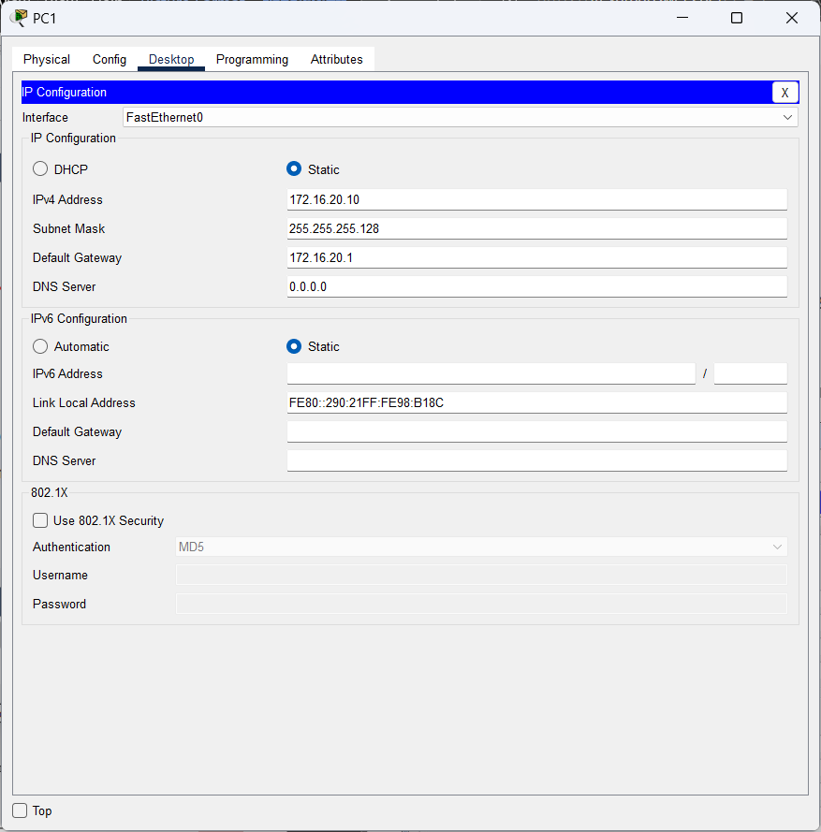

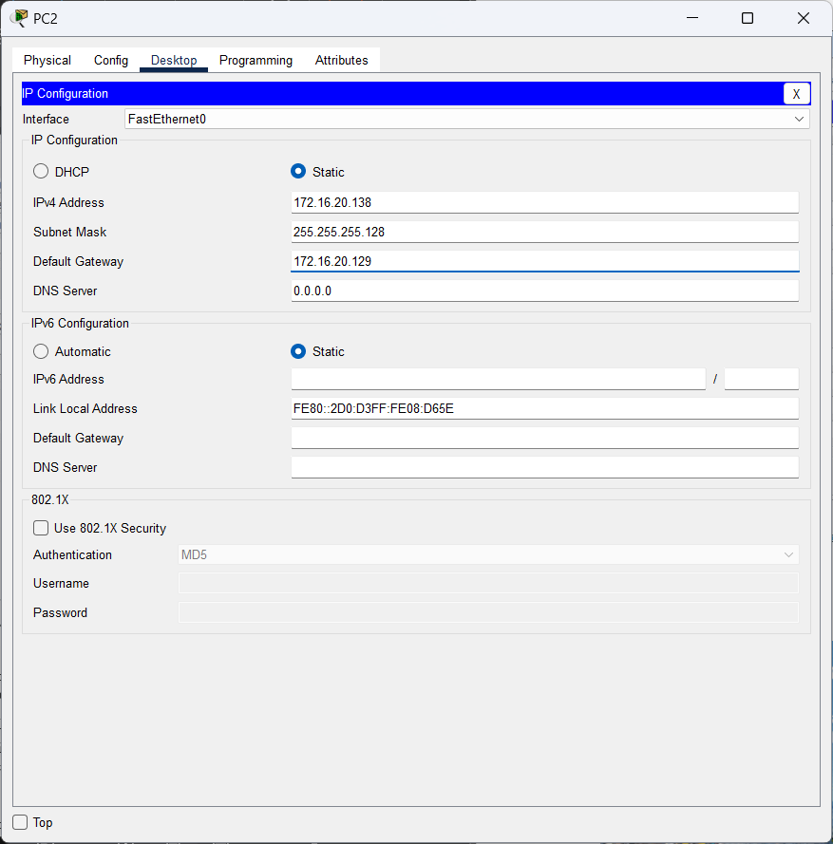

**Step 2: Verify connectivity.**

**PC1** and **PC2** should be able to ping each other and the **Dual Stack Server**.

**Answer:**

Then, we ping PC2 through PC1

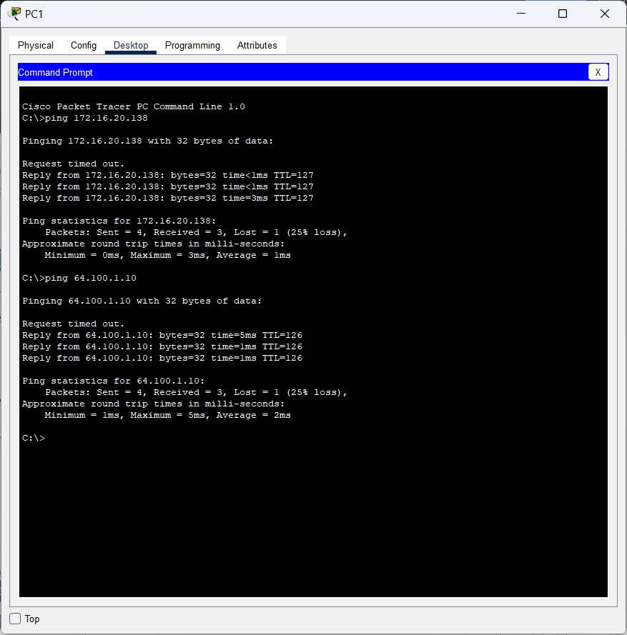

**Part 2: Configure IPv6 Addressing and Verify Connectivity**

**Step 1: Assign IPv6 addresses to R2 and LAN devices.**

Referring to the **Addressing Table**, configure IP addressing for **R2 LAN interfaces**, **PC3** and **PC4**. The serial interface is already configured.

**Answer:**

With this command, the two Gigabit Ethernet interfaces on router R2 are configured with their respective IPv6 addresses and enabled. This allows the router to direct network traffic between two different IPv6 subnets, connecting devices in subnet 2001:db8:c0de:12::/64 and subnet 2001:db8:c0de:13::/64.

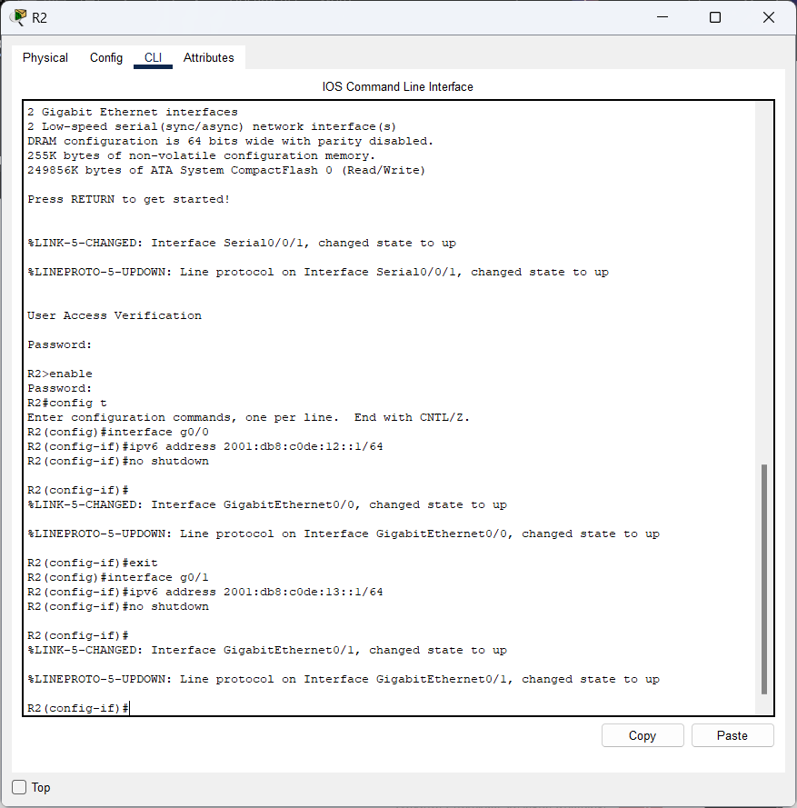

Then, we will fill in the IPv6 address, and default gateway that we configured in R2.

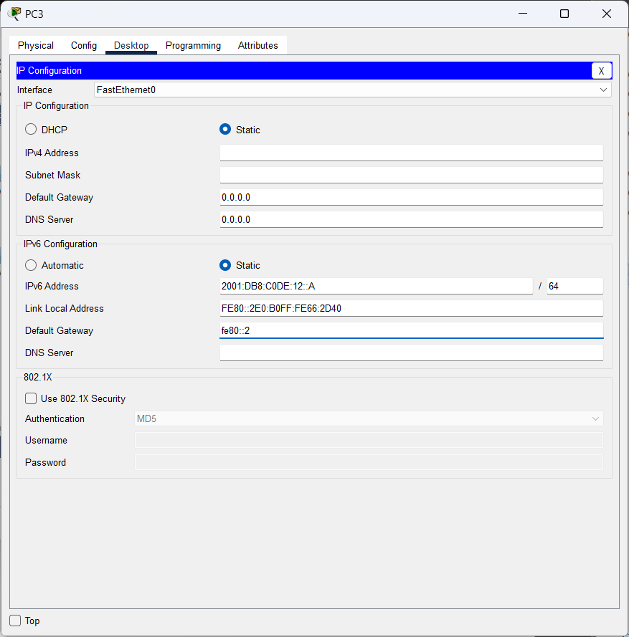

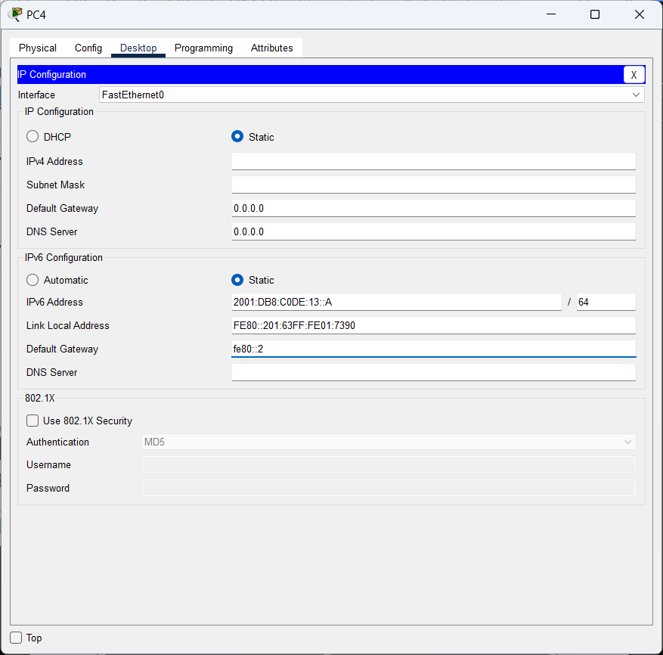

**Step 2: Verify connectivity.**

**PC3** and **PC4** should be able to ping each other and the **Dual Stack Server**.

**Answer:**

After that, we ping from PC3 to PC4 from the IPv6 address.

